

**\*\*\*\*\*\*\*\*\*MEDIA ALERT\*\*\*\*\*\*\*\*\***

**Labrinth wears NEW Ray-Ban Reverse Collection to the MET GALA (available Mid-May)**

British singer, rapper, and songwriter, **Labrinth**, wore the newly launching, innovative **Ray-Ban Boyfriend Reverse** sunglasses to the MET Gala on May 1st. Available for pre-order on May 4th and available for purchase early July.. The Ray-Ban Reverse Collection features a lens like you’ve never seen and is made for consumers who are true to themselves while still embracing new trends. Inspired by avant-garde design and fluid identities, the Ray-Ban Reverse will encourage you to go beyond boundaries and investigate unexplored aesthetics.

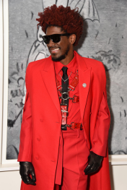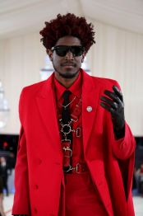

**Photo Credit: Getty**

**Usage courtesy of RAY-BAN**

**Please see HERE for all GRATIS images of Labrinth**

**Brand:** Ray-Ban

**Collection Name:** Reverse



**Find Similar Styles (Ray-Ban Reverse Collection will be available for purchase May 15th):** HERE **Starting Price:** $185